HemoSim edit doc - I1
HOW TO USE: edit the wording directly (Track Changes if you like). For layout or a figure (size, position, wrong/missing image) write a short instruction in [brackets] right where it applies. Send it back and I apply the wording to the page and the layout notes to the styling, then regenerate. This is a content+notes doc, so it will not look exactly like the web page.
[In the modules, you often refer to another module. This should only be done rarely and when an explicit nod to another module is needed. Remember, the reader is learning not cataloging facts. When another module could be referenced, create a link to that module right there. These links should always open as a new tab so the original location of the reader is not lost.]
[You frequently reference authors and the entire study they did. This is not necessary. Instead, it is okay to simply summarize the salient teaching point from the study needed to support the argument you are making. Next, cite the reference number right in the text that corresponds to the citation number of the manuscript at the end of the module. In addition, if a reader clicks on the citation number it should take them either directly to the article or to the appropriate reference in the bibliography at the end of the module This allows readers to quickly identify (and read, if interested) the appropriate reference material upon which the claim is built.]

[Instead of categorizing the modules into “Novice, Informed Learner, and Expert” change all references to “Novice”, “Core”, and “Expert” throughout the entire website]

Physiologic foundations
In the Novice modules, we identified a working map of the circulation [link back to N4 here for reference]: one closed loop, four interfaces, and a single equation that fits all of them. That map is enough to reason with at the bedside. But it is not finished. The Core modules rebuild each of the principles from its foundations, says what each one actually claims, and where each one stops being true.
The cardiovascular system can be described as volume, a pump, pipes, and a microcirculation. Volume is the circulating blood, which sits overwhelmingly in the venous compartment and sets the pressure that drives return. The right side of the pump preserves this flow by maintaining a low downstream pressure, while the left side of the pump generates the pressure gradient that ultimately drives blood through the systemic circulation. The pipes, principally the arterioles, set how that gradient is spent and where flow is directed, while the large elastic arteries act as a Windkessel that converts an intermittent ejection into near-continuous downstream flow. The microcirculation is where the entire enterprise is finally cashed out as oxygen crossing a capillary wall.

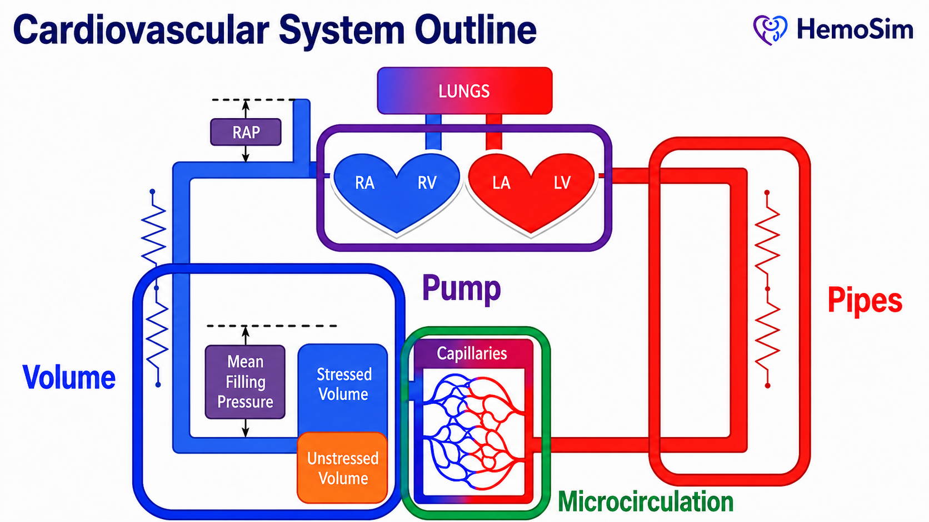
Replace the existing picture with the one above. Change the caption below it to read “The coarse model. Volume, pump, pipes and microcirculation; these name the four things that can be manipulated. The four-interface model refines this by naming the boundaries between them. This is where hemodynamic problems actually live.”]
[Layout note: make this picture a large as it can be to fit within the page]
The four-interface model is a refinement of that picture rather than a replacement for it. Its improvement is that it stops describing components and starts describing boundaries. A patient in shock rarely has a single broken component. What they have is a mismatch between two components that are supposed to be matched. The goal is finding tools to identify where the mismatch is.

Why a model at all, and why not a pump and pipes
Every clinician carries a mental model of the circulation, whether or not they consciously recognize it. One simple model involves a system where a pump drives fluid around a circuit of pipes, the pump sets the flow, the pipes set the pressure.
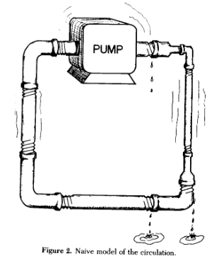
[Replace the existing picture with the cropped picture above]
The naive model of the circulation. A pump, rigid pipes, and a fixed circuit. Almost every feature of this drawing is wrong in a way that matters clinically. Sylvester JT, Goldberg HS, Permutt S. Clin Chest Med. 1983;4(2):111-126 (reference 1).
[Layout note: figure shown small here. On the web it is currently capped at 400px wide. Say if you want it smaller/larger, moved, cropped, or replaced.]
It is worth spending time on why this model fails, because most bedside hemodynamic errors assert themselves when we revert to an overly simplistic plumbing model. There are at least five distinct failures in this model, and each one maps onto a specific clinical mistake.
The pump does not set the flow. In a plumbing circuit the pump is the source of flow and raising its rate raises output. In the circulation the heart cannot eject volume that has not been delivered to it. In other words: the heart cannot pump out more volume than comes back via the venous circulation. Contractility and heart rate determine how completely the heart clears what arrives, and beyond that point they buy nothing. This is why an inotrope in a patient with an empty venous reservoir produces a faster, emptier heart rather than more flow.
The venous pipes are mostly a reservoir. Over 70 percent of total blood volume exists in the systemic veins and venules at low pressure. Calling these vessels pipes is a category error. They are better understood as a capacitance reservoir: a compliant compartment built to hold large amounts of blood with relatively little rise in pressure. This is possible because the compliance of small venules and veins is almost forty times greater than that of arterial vessels. That asymmetry does more work in hemodynamics than almost any other single factor, and we return to it under Principle 2.
Most of the volume does nothing. Only the fraction of blood that distends vessel walls beyond their unstretched shape generates a distending pressure, and only that fraction can drive flow, that’s also known as stressed volume. Stressed volume is usually about 30 percent of total volume. Magder and De Varennes measured it directly in five patients undergoing hypothermic circulatory arrest by draining the patient into the bypass reservoir once the pump was stopped, and found a stressed volume of 20.2 plus or minus 1.0 mL/kg, [change this and all similar descriptions of standard deviation to a format of “20.2 (S.D. +/- 1.0 ml/kg)” For interquartile ranges list them as “XX [IQR xx-xx]”] This amounts to about 30 percent of predicted blood volume. A plumbing model has no way of expressing the idea that two thirds of the fluid in the circuit is hemodynamically inert but recruitable. Once the venous side is understood as a reservoir rather than a simple pipe, the arterial side can be considered separately. Here the vessels behave more like distribution pipes, but even this analogy quickly fails.
Flow in a vascular pathway can stop before pressure reaches zero. In a rigid pipe, flow ceases when the pressure difference along it reaches zero. In the arterial circulation, small vessels can stop conducting flow while downstream pressure is still positive because they are collapsible, tone-generating structures. When vasomotor tone exceeds the local distending pressure needed to keep the lumen open, the vessel effectively narrows or collapses. The clinical translation is that the downstream pressure for arterial flow is the arteriolar critical closing pressure and not the right atrial pressure. This error in the plumbing picture is significant, but also explains why SVR is not simply equal to MAP-RAP/CO.
The circuit is regulated, not fixed. Pipe caliber is a property of the plumbing. Vessel caliber is a controlled variable, adjusted regionally and second to second by neural tone, circulating catecholamines, local metabolites and endothelial signaling. Two patients with identical cardiac output and identical mean arterial pressure can have entirely different distributions of that flow, and the plumbing model has no vocabulary for the difference.
What plumbing erroneously predicts | What the circulation does | Where it misleads at the bedside
The pump sets flow | Return sets flow, the pump permits it | Inotropes for an underfilled ventricle don’t improve flow
Pipes conduct, they do not store | Over 70 percent of volume is stored in compliant veins | Treating the venous system as passive
All fluid in the circuit drives flow | Only the stressed fraction does, roughly 30 percent | Equating total body water with preload
Flow stops at zero gradient | Vesel characteristics create regions of flow that adhere to the principles of a Starling resistor | Calculating SVR using RAP
Pipe caliber is fixed | Caliber is actively regulated, regionally | Assuming a good MAP means good regional flow and perfusion

A different model a model that remains simple enough to conceptualize, but also avoids the five errors above is the four-interface model we introduced earlier in the Novice modules [link to appropriate novice module here]. This model assumes three basic principles, outlined below.

Principle 1: the circulation has four main interfaces
We took an initial look at the four interfaces in the Novice modules. As we dig deeper into the interfaces, it is important to consider that
an interface in this model is not simply a location in the circulation. It is a boundary that satisfies three conditions.
- There is an upstream pressure and a downstream pressure.
- There is a resistance between them across which the gradient is dissipated.
The two sides can become uncoupled, meaning that the upstream side can be performing adequately by its own measures while the handoff across the boundary fails. That third condition is new to us at this point and is something we’ll spend a lot of time examining in the upcoming modules.

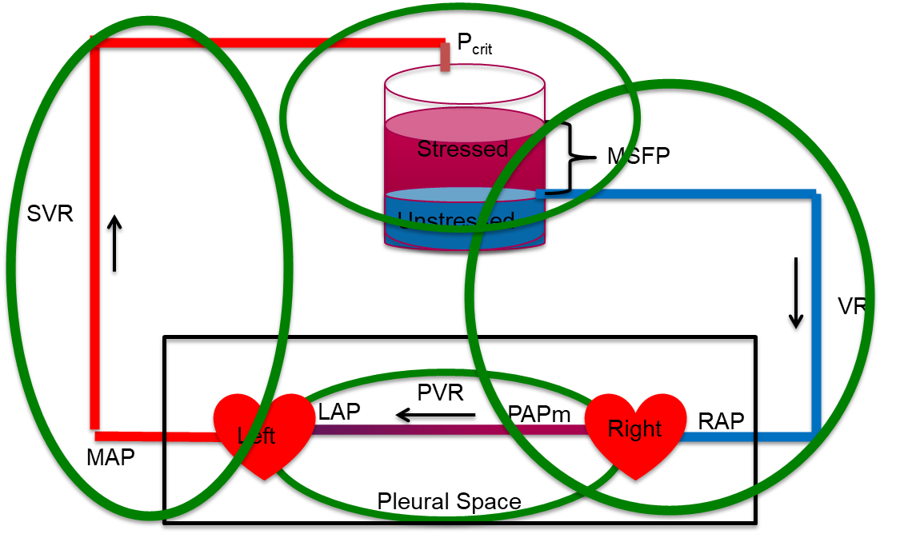
All four interfaces on one loop. The arterial limb runs from MAP across SVR to the arteriolar critical closing pressure. The reservoir holds the stressed and unstressed volume, whose distending pressure is Pms. The venous limb runs from Pms across the resistance to venous return down to RAP. The pulmonary circuit runs from PAPm across PVR to LAP, and it, together with both hearts, sits inside the pleural space. The reservoir label MSFP in this figure is the mean systemic filling pressure, written Pms throughout this curriculum.
[Layout note: figure shown small here. On the web it is currently capped at 640px wide. Say if you want it smaller/larger, moved, cropped, or replaced.]
Interface | Upstream | Downstream | Resistance | What uncoupling looks like
I. LV to arterial system | MAP (Mean arterial pressure) | Pcrit (Critical closing pressure in the arterial tree) | SVR (Systemic vascular resistance) | Adequate contractility, inadequate stroke volume, because arterial load and ventricular elastance are mismatched
II. Arterioles to capillaries | Pcrit | Pms (Mean systemic filling pressure) | Arteriolar and capillary resistance | Acceptable MAP with prolonged capillary refill and mottling, the macro-to-micro dissociation
III. Capillaries to right atrium | Pms | RAP (Right atrial pressure) | Rv (Venous resistance) | Rising RAP acting as tissue afterload, impaired drainage and interstitial edema despite stable macro-hemodynamics
IV. RV to pulmonary artery | PAPm (Mean pulmonary artery pressure) | LAP (Left atrial pressure) | PVR (Pulmonary vascular resistance) | A right ventricle that cannot raise its output against a rising pulmonary load
Two structural facts about this table are worth stating explicitly, because neither is obvious and both are important.

The downstream pressure of one interface is the upstream pressure of the next

The four interfaces are in series around a closed loop, and their pressure terms interlock. Interface I ends at Pcrit, which is where Interface II begins. Interface II ends at Pms, which is where Interface III begins. Add the systemic drops together and the intermediate terms cancel:
(MAP − Pcrit) + (Pcrit − Pms) + (Pms − RAP) = MAP − RAPThe three systemic interface gradients sum to the total systemic pressure drop. Because cardiac output is common to all three terms, the total systemic resistance is the sum of the three interface resistances.
It is vital to recognize what this sum actually means. The drop in pressure from P_{crit} to Pms does not occur on account of a vascular resistance per se, meaning that resistance, in the conventional sense is not dissipating that gradient in the way it may appear to the casual observer. Instead, the drop occurs because of a vascular waterfall and a Starling Resistor behavior, a region where flow is governed by a maximal gradient which is dependent on the physical properties of the vessel, irrespective of the downstream pressure below the waterfall, [link to appropriate page describing this phenomenon]. Despite the waterfall effect, the algebra above still holds and is still the right way to keep the interfaces in order. It is the interpretation of how the waterfall affects flow that needs care. It is also important to understand how manipulations to Pcrit can affect hemodynamic perfusion significantly, despite seemingly inconsequential changes to the upstream MAP or the downstream RAP [link to I5].
This is also why measuring the mean arterial pressure and a right atrial pressure gradient, tells you the total but not the distribution within the circuit. Two patients with identical MAP and identical RAP can have completely different splits of that gradient across the three interfaces, and the split is where the diagnosis is often made.

The pulmonary circuit is a separate accounting, sharing one variable
Interface IV is not in series with the systemic gradient in the same arithmetic sense. It has its own upstream and downstream pressures, PAPm and LAP, and its own resistance. What ties it to the other three is cardiac output, which in the steady state is identical on both sides of the heart. That single shared term is what makes a right-sided problem present as a left-sided one too. A right ventricle that cannot generate flow across a high pulmonary vascular resistance limits left ventricular filling, and no amount of left-sided contractility can overcome that.
Rola and colleagues formalized this reading of the model, arguing that shock should be approached interface by interface and that therapy should target the weakest link rather than a population-level pressure target (ie: MAP >60-65). Their worked example is instructive: a patient with a hyperdynamic left ventricle and a persistently low stroke volume in whom neither vasopressor titration nor fluid loading restored perfusion because the limiting lesion was right ventricular to pulmonary arterial uncoupling at Interface IV. The intervention that worked was the one aimed at the failing interface.
One final structural point. The thoracic cavity contains both the right and left heart and the entire pulmonary circuit, and every breath, spontaneous or mechanical, changes the pressure surrounding all of them at the same time. Heart-lung interaction is a perturbation applied simultaneously to Interfaces I, III and IV. We explore this further in modules I12 and I13.

Principle 2: the circulation loop is closed, so return and output must balance
The second principle is a conservation statement. The circulation is a closed loop system. Over any meaningful interval, whatever leaves the left ventricle returns to the right atrium. Venous return and cardiac output are not two problems. They are one quantity viewed from two ends.
The Novice modules explored this concept in its infancy by connecting equations through a common denominator of cardiac output [link to appropriate novice module here]. Three refinements improve upon the principle.

The equality holds on average, not instant to instant

Right and left ventricular outputs are equal when averaged over several cardiac cycles, and they are routinely unequal within a single respiratory cycle. This is not a technicality. It is the physical basis of every dynamic index of fluid responsiveness that this curriculum teaches. For example, mechanical ventilation induces cyclic changes in vena caval flow, then pulmonary arterial flow, then aortic flow, and the resulting swing in arterial pressure is what pulse pressure variation measures. Principle 2 is a statement about the time average, and deviations from it carry important clinical information.

The compliance asymmetry explains why transient mismatch is small and self-correcting

If the two sides of the loop can differ transiently, what prevents the system from running away? The compliance asymmetry between the venous and arterial tree stabilize the system. Venous compliance is almost forty times arterial compliance. Move a small volume from the veins into the arteries and arterial pressure rises appreciably while venous pressure falls only slightly. The rise in arterial pressure increases flow out of the arterial compartment and the fall in venous pressure reduces the gradient driving return, so both changes oppose the shift that produced them. The loop is a negative feedback system by virtue of its geometry alone, keeping the system in check.
The same asymmetry explains a fact that otherwise looks paradoxical. A cardiac output that has increased five-fold, as it does in a young healthy adult during exercise, can occur with only small changes in stressed blood volume. Flow is not set by how much volume there is. It is set by the pressures that volume generates and the resistances it must cross, and both of those can change enormously without a drop of fluid moving in or out of the body.

The intersection of two curves serves as a bookkeeping device, not a causal claim

The familiar graphs below place the venous return curve and the cardiac function curve on shared axes; flow on the y-axis and right atrial pressure on the x-axis. Because both functions relate the same two variables, their intersection serves as the operating point.
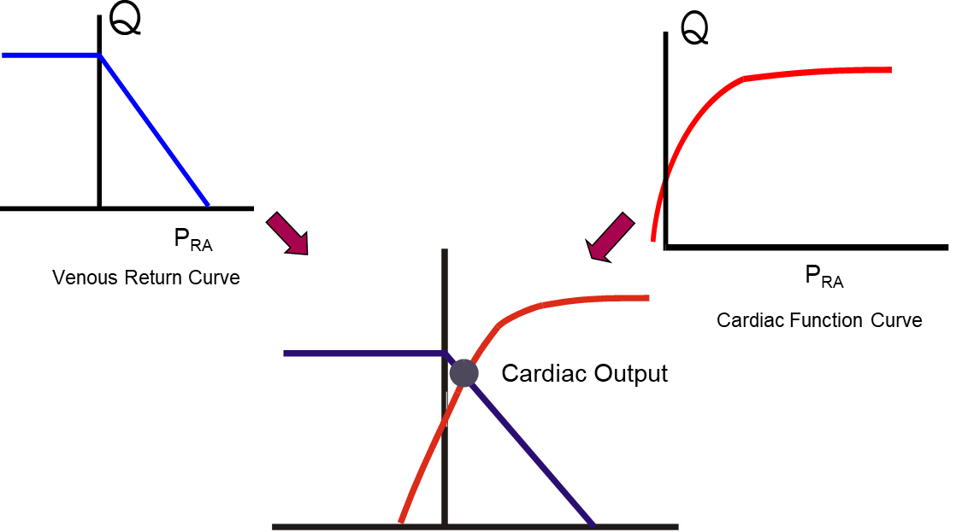
Two functions of the same two variables. Only one flow and one right atrial pressure satisfy both at once, and that pair is the operating point. The construction shows which function has moved. It does not show which one caused the move.
[Layout note: figure shown small here. On the web it is currently capped at 640px wide. Say if you want it smaller/larger, moved, cropped, or replaced.]
What the graphs do not establish is causation. A causal evaluation of Guyton's 1955 manuscript on venous return suggests that right atrial pressure acts as a back pressure limiting venous return. This notion has been contested under the premise that Guyton’s preparations set flow with a pump and measured right atrial pressure as the result. Guyton’s curve puts the manipulated variable (flow) on the y-axis and the observed variable (right atrial pressure) on the x-axis. This is the reverse of convention, and it invites the casual observer to potentially deduce a causal direction Guyton’s experiments that were never tested. Since right atrial pressure was measured rather than imposed, the experiment did not actually test whether right atrial pressure limits flow. Acknowledging this, others have come to Guyton’s defense with equal force. After considering arguments from both camps, it is probably safe to say that central venous pressure is indeed an important physiologic parameter but shouldn’t be seen simply as an independent variable that directly determines cardiac output. We will revisit this further in Module I10.

[Physiologic Insight box: Treat the two-curve diagram as a way of asking which function moved, not as a mechanism. A patient whose cardiac output has fallen with a rising right atrial pressure has moved along the venous return curve because the cardiac function curve dropped, which localizes the problem to the pump. A patient whose cardiac output has fallen with a falling right atrial pressure has moved along the cardiac function curve because the return function dropped, which localizes the problem to volume or venous tone. Same fall in flow, opposite direction of right atrial pressure, opposite treatment. This is a sound way to put right atrial pressure to work at the bedside, as the variable that says which of the two functions has moved.]

What Pms actually is, and what it measures
The mean systemic filling pressure is the pressure that would be measured everywhere in the systemic circulation if flow were stopped and pressures allowed to equilibrate. It is a property of the stressed volume and the compliance of the vessels holding it, and it is not a property of the heart. The roots of this premise were expressed by a famous experiment by Bayliss and Starling, described in a prior module [link to N4].
In the prior modules, we discussed that healthy humans likely have a Pms ~ 8 to 10 mmHg. This estimate comes from classical animal preparations. However, later publications on humans at the bedside estimate a considerably higher Pms. Maas, Pinsky and colleagues studied eleven mechanically ventilated postoperative cardiac surgical patients across three physiologic states, supine, thirty degrees head-up tilt, and after 500 mL of colloid, and derived Pms three ways. Inspiratory hold maneuvers gave a mean of 20.9 plus or minus 5.6 mmHg, an arm equilibrium pressure method gave 19.8 plus or minus 5.7 mmHg, and a model analog gave 14.9 plus or minus 4.0 mmHg. The first two agreed closely enough to be interchangeable, the model analog read systematically about 6 mmHg lower, and all three tracked the same direction of change with tilt and with volume loading.
Two lessons sit in these numbers. The first is that a textbook value obtained in an anesthetized animal may differ considerably from a ventilated patient on vasopressors. The second is more generally useful: the three methods disagreed on the absolute value and agreed on the direction of change. That pattern recurs throughout hemodynamic monitoring, and it is the reason this curriculum repeatedly favors trends over absolute numbers.
The venous return curve, its slope, its plateau and the manipulation of Pms are the subject of modules I7 and I8, and the full treatment of the intersection is module I10.

Principle 3: one hydraulic relationship describes every interface
The third principle is the one most often quoted and least often examined. It states that across every interface, the pressure gradient equals cardiac output multiplied by the resistance of that interface. It is usually attributed to Hagen and Poiseuille, and the attribution is worth unpacking, because what the law actually says and what we use it for are not the same thing.
Poiseuille's law in full states that flow through a tube is proportional to the pressure gradient and to the fourth power of the radius, and inversely proportional to viscosity and to length:
Q = ΔP × πr4 ÷ (8ηL)Q, flow; ΔP, pressure difference across the tube; r, radius; η, viscosity; L, length. Collecting everything except the pressure gradient into a single term R gives ΔP = Q × R, the form used clinically.
Secomb's review of hemodynamics states the five conditions the derivation requires: that the tube is a uniform rigid circular cylinder, that the fluid is Newtonian (where shear stress is directly proportional to shear rate), that flow is steady, that flow is laminar, and that flow is not subject to entrance effects. The circulation violates all five. Vessels are distensible and taper. Blood has significant non-Newtonian properties, although it is reasonable to treat it as Newtonian in the larger arteries. Flow is pulsatile rather than steady. Flow is disturbed at bifurcations and in the great vessels. Branch points are entrance effects almost everywhere.
None of that makes the clinical form useless, but it does change what the form is. ΔP = Q × R is not a physical law being applied. It is a definition of R. Resistance in hemodynamics is not measured. It is calculated, as whatever number makes the observed gradient and the observed flow consistent. Every physical effect the equation ignores, including pulsatility, distensibility, non-Newtonian behavior and turbulence, is absorbed silently into the resistance number. The equation forces the three quantities (flow, pressure and resistance) into a fixed relationship, so that knowing any two constrains the third; a powerful bedside property in practice.

Two consequences of taking the fourth power seriously
Although Poiseuille's law does not describe the circulation quantitatively, its radius dependence is directionally right and clinically enormous. Resistance varies with the inverse fourth power of diameter: a 16 percent decrease in diameter doubles flow resistance. This is why arteriolar smooth muscle, moving vessel caliber over a modest range, can dominate systemic resistance, and it is why the pressure drop in the systemic circulation is concentrated on the arterial side, specifically in the small arteries and arterioles.
It also explains an asymmetry that catches people out on the venous side. The venules and small veins have an enormous aggregate cross-sectional area and therefore contribute very little to the resistance to venous return, despite holding most of the blood. The resistance that matters on the venous side sits in the large veins and the venae cavae, where cross-sectional area is small. Volume and resistance live in different parts of the venous system, which is why a maneuver that changes venous capacitance and a maneuver that changes venous resistance are not the same maneuver.

Resistance is calculated, and what it is calculated from matters
The systemic vascular resistance reported by every monitor is computed as follows:
SVR = 80 × (MAP − RAP) ÷ COMAP, mean arterial pressure (mmHg); RAP, right atrial pressure (mmHg); CO, cardiac output (L/min).
Compare this with the Interface I relationships in the table above and the discrepancy is immediate. The physiologic downstream pressure for arterial flow is the arteriolar critical closing pressure, not the right atrial pressure. Because Pcrit is normally well above RAP, and because vasoactive drugs move Pcrit, the calculated SVR above systematically overstates the arterial gradient and can move in the wrong direction when a drug shifts Pcrit more than it shifts the resistance itself. Magder has made this argument at length in the context of what a blood pressure target actually means. The practical instruction is not to discard SVR as calculated above, which remains useful as a trend, but to remember that it is a derived index containing a known physiologic error, not a measurement of arteriolar tone.

The same relationship generates three vascular waterfalls
When the pressure surrounding a collapsible vessel exceeds the pressure inside it, or when the active tension of the vessel surpasses its intraluminal pressure, transmural pressure falls to or below zero and the vessel collapses. Flow through such a segment is then governed by the difference between the upstream pressure and the surrounding pressure, and lowering the downstream pressure further produces no additional flow. Permutt and Riley described this as a vascular waterfall, by analogy with the fact that the height of the drop below a waterfall does not affect the flow over its lip. It is the same phenomenon as a Starling resistor.
This is not an exotic special case. It is the standard behavior of a collapsible vessel with tone, and it occurs at three separate places in the loop that this curriculum cares about.
Where | Collapsible segment | Surrounding pressure | Consequence
Interface I and II | Arterioles | Tissue pressure plus vessel tone, expressed as Pcrit | Arterial flow ceases at a positive pressure, so the true perfusion gradient is MAP minus Pcrit
Interface III | Great veins entering the thorax | Abdominal pressure, near zero, and pleural pressure | The plateau of the venous return curve, below which a lower RAP recruits no further flow
Interface IV | Pulmonary capillaries | Alveolar pressure | The West zone behavior that determines whether a wedge pressure reflects left atrial pressure
Recognizing that these are one phenomenon rather than three unrelated facts is a large part of what the core tier is for. Each is developed separately later, in I6, I8 and I15 respectively, but the physics is identical and learning it once is enough.

Cardiac output is the common denominator
Writing the relationship out for each interface produces four equations that differ only in which pressures and which resistance appear. Cardiac output appears in all of them, and in the steady state it is numerically the same in all of them.
[replace the graphic with one you create using the 4
interface equations outlined in module N4]

[Layout note: figure shown small here. On the web it is currently capped at 640px wide. Say if you want it smaller/larger, moved, cropped, or replaced.]
Two things follow. The first is arithmetic. Because Q is common, the ratio of any two pressure gradients equals the ratio of the two resistances, without needing to know Q at all. If the arterial gradient is large and the venous gradient is small, the arterial resistance is proportionately larger, and that inference is available from pressures alone.
The second is why this module sits where it does in the curriculum. Oxygen delivery is the organizing goal of the whole enterprise, and DO2 equals cardiac output multiplied by arterial oxygen content. The same term that appears in every hydraulic equation appears in the delivery equation. Cardiac output is the hinge between the mechanics of the circulation and the purpose of the circulation, which is why so much of hemodynamic assessment reduces to establishing what it is and what is limiting it.

What the three principles buy you
Taken together the three principles are not three facts. They are a method, and it is worth stating what each contributes so that the rest of this pathway has something to hang on.
Principle 1 tells you where to look. Circulatory failure is a boundary failure, and the four interfaces enumerate the boundaries. When the Novice method asks you to create a physiologic hypothesis, the useful form of that hypothesis is a named interface, because a named interface implies both a test and a therapy.
Principle 2 tells you what cannot be true. Return and output balance over time, so any account of a patient that requires them not to balance is wrong. It also tells you that the balance is struck at a single operating point that two functions determine jointly, so an intervention that moves one function has predictable effects on both flow and filling pressure. Watching which of the two moved, rather than watching either alone, is the discipline.
Principle 3 tells you how to reason quantitatively once you have located the problem, and, just as importantly, how far that reasoning can be trusted. Gradient equals flow times resistance is exact by definition and empty by itself. Its value lies in constraining three quantities so that two of them determine the third, and its danger lies in the resistances, which are residual terms that quietly absorb every effect the equation ignores.
Those three tools describe a circulation. They do not yet describe a patient. The next module takes the model to the bedside and asks what happens when the one number everybody reaches for first, the blood pressure, looks acceptable and the patient is nonetheless in shock.

References
To DROP a reference, strike it. To ADD one, write [add: author, year, journal, roughly what it is] rather than typing the citation out. Do not correct the text of an entry here: every author list, volume, issue, page range, year and DOI is fetched from PubMed when the page is rebuilt, so an edit made here is discarded and a typo made here is caught. This list is what the page currently carries.
1. Sylvester JT, Goldberg HS, Permutt S. The role of the vasculature in the regulation of cardiac output. Clin Chest Med. 1983;4(2):111-126. PMID 6342918.
2. Magder S. Volume and its relationship to cardiac output and venous return. Crit Care. 2016;20(1):271. doi:10.1186/s13054-016-1438-7. Free full text.
3. Magder S, De Varennes B. Clinical death and the measurement of stressed vascular volume. Crit Care Med. 1998;26(6):1061-1064. doi:10.1097/00003246-199806000-00028.
4. Magder S. Starling resistor versus compliance. Which explains the zero-flow pressure of a dynamic arterial pressure-flow relation? Circ Res. 1990;67(1):209-220. doi:10.1161/01.RES.67.1.209.
5. Rola P, Kattan E, Siuba MT, Haycock K, Crager S, Spiegel R, Hockstein M, Bhardwaj V, Miller A, Kenny JE, Ospina-Tascon GA, Hernandez G. Point of View: A Holistic Four-Interface Conceptual Model for Personalizing Shock Resuscitation. J Pers Med. 2025;15(5):207. doi:10.3390/jpm15050207. Free full text.
6. Michard F. Changes in arterial pressure during mechanical ventilation. Anesthesiology. 2005;103(2):419-428. doi:10.1097/00000542-200508000-00026.
7. Guyton AC. Determination of cardiac output by equating venous return curves with cardiac response curves. Physiol Rev. 1955;35(1):123-129. doi:10.1152/physrev.1955.35.1.123.
8. Beard DA, Feigl EO. Understanding Guyton's venous return curves. Am J Physiol Heart Circ Physiol. 2011;301(3):H629-H633. doi:10.1152/ajpheart.00228.2011. Free full text.
9. Andrew P. CrossTalk proposal: Guyton's venous return curves should be taught. J Physiol. 2013;591(23):5791-5793. doi:10.1113/jphysiol.2013.261438. Free full text.
10. Beard DA, Feigl EO. CrossTalk opposing view: Guyton's venous return curves should not be taught. J Physiol. 2013;591(23):5795-5797. doi:10.1113/jphysiol.2013.260034. Free full text.
11. Berlin DA, Bakker J. Starling curves and central venous pressure. Crit Care. 2015;19(1):55. doi:10.1186/s13054-015-0776-1. Free full text.
12. Magder S. Bench-to-bedside review: an approach to hemodynamic monitoring, Guyton at the bedside. Crit Care. 2012;16(5):236. doi:10.1186/cc11395. Free full text.
13. Maas JJ, Pinsky MR, Geerts BF, de Wilde RB, Jansen JR. Estimation of mean systemic filling pressure in postoperative cardiac surgery patients with three methods. Intensive Care Med. 2012;38(9):1452-1460. doi:10.1007/s00134-012-2586-0. Free full text.
14. Secomb TW. Hemodynamics. Compr Physiol. 2016;6(2):975-1003. doi:10.1002/cphy.c150038. Free full text.
15. Magder S. The highs and lows of blood pressure: toward meaningful clinical targets in patients with shock. Crit Care Med. 2014;42(5):1241-1251. doi:10.1097/CCM.0000000000000324.
16. Permutt S, Riley RL. Hemodynamics of collapsible vessels with tone: the vascular waterfall. J Appl Physiol. 1963;18:924-932. doi:10.1152/jappl.1963.18.5.924.

